Rocket propulsion & electronics(CPU-satellites)

Here in this text I will document some of the most important aspects of rocket propulsion variables, acoustic instabilities, correlations in variable research and one special part for logic design in the electronics cobblestone or electronic networks for Rockets & satellites to catch signals with new algorithms and arguments to reason about the possibility to reduce cost for small rockets for homes. The possibility to launch new inventions to space with enough knowledge and materials.

* Waves
* Rocket-propulsion
* electronics

**Waves-correlations**(214)

ω is a real number characterizing the frequency of the wave. The dispersion relation is thus solved for fixed values of (R, x, ω) (and additionally with the azimuthal wavenumber m being fixed for the axisymmetric geometry) and the complex α value is computed in order to satisfy the dispersion.

Norm of the longitudinal and transverse velocity component of the eigenmode α = 4.0037 − i0.366 obtained for R = 900, x = 10 and ω = 31.6

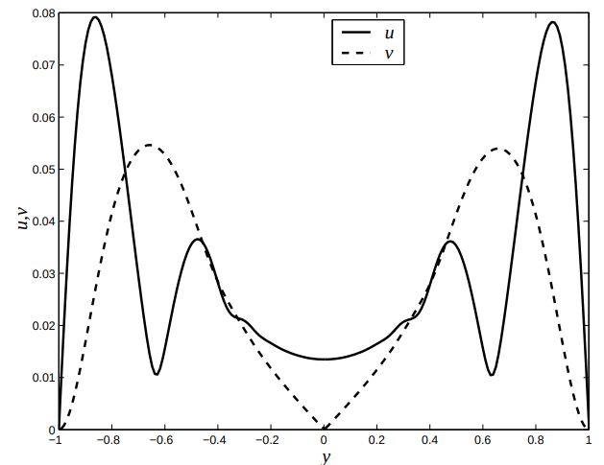

**Factors-logarithms**

The factor n gives the logarithm of the eigenmode amplitude. In one factor-equation oscillator, the variable x0 is the neutral position. If it exists, it is the point for given values of (R, ω) which separates upstream a stable region and downstream an unstable region. Generally, x0 depends in fact on (R, ω), so that we may write x0 = x0(R, ω).

| x0(R, ω) |
| --- |

The Reynolds number R is fixed : R = 4000. Then, the growth rate −αi is computed for different frequencies, and for different values of x. Finally, for each considered frequency, the growth rate is integrated leading to the n factor.

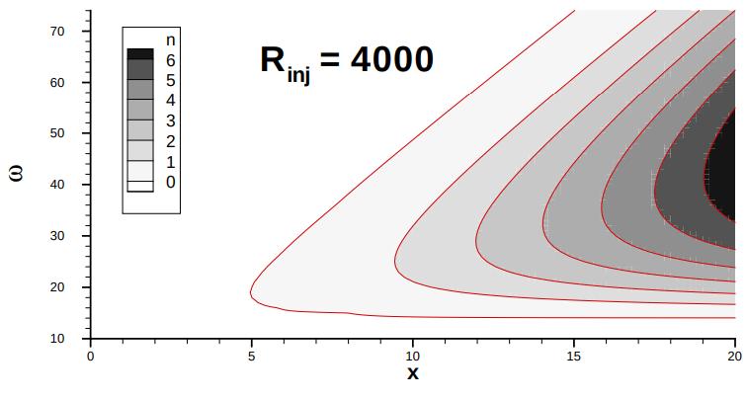

The factor (w) and (R)R quantifies the amplification, for example, at x = 20, the maximum of the n factor is close to 7, it means that the perturbation is e 7 ' 1000 times larger than the perturbation at x = 5.

**Steps for the curve-perturbation;**

R quantifies the amplification, for example, at x = 20, the maximum of the n factor is close to 7, it means that the perturbation is e 7 ' 1000 times larger than the perturbation at x = 5.

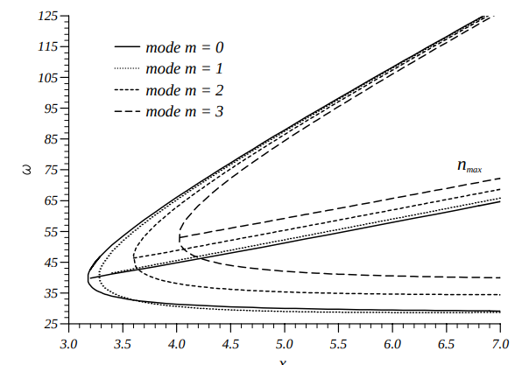

**Marginal curves** for m = 0, 1, 2, 3, R = 4000

Analyzing the real part of the complex wave number α. It is then more suitable to work with the wavelength λ which is defined by : λ = 2π/αr. The iso-λ values, always in a (x, ω) diagram for the axisymmetric geometry with R = 4000 and m = 0

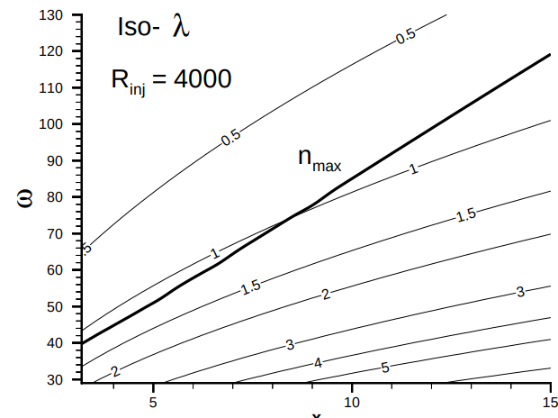

Analyzing wave-curve effects over rockets in the atmosphere & the outer space & however, the effects of :

• compressibility,

• real geometry,

• presence of an acoustic mode,

• Regression of the boundary wall has been found to be nearly completely negligible.

by a norm such as the maximum with respect to y, the ratio is simplified into V / ¯ U¯ = 2/πx, which indicates that, according to this choice of norm, the non parallel effects decrease with respect to x (the ratio is smaller than 0.05 for x ≥ 15

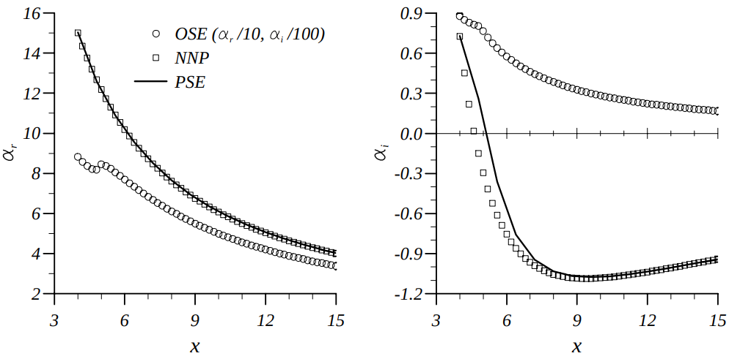

**Geometric-reasons for waves that intercept physical layers in spatial rockets;**

The basic reason comes from the linear form uϕ = 1 2 (ˆu exp(iω) + ˆu ∗ exp(−iω))

of the physical fluctuation (where z ∗ represents the complex conjugate of z). The quadratic terms in the Navier-Stokes equations are formally expressed by the product uϕuϕ. The product is converted into a sum of the exponential terms, leading thus to the frequencies 2ω and 0.

(220)

**Combustion Instabilities in Solid Propellant Rocket Motors**

**Combustion processes** are sensitive to the macroscopic °ow variables, particularly pressure, temperature and velocity. Combustion instabilities occur in frequency ranges in variables such

the transient changes of energy release in phase with imposed changes of a °ow variable such as pressure.In tests of full-scale propulsion systems, only three types of data are normally available; obtained from pressure transducers, accelerometers, and strain gauges. Measurements of pressure

**The combustion** processes behave as a dynamical system characterized by a single time delay or relaxation time. The dynamics of burning solid propellantsThe flow separation rates are involved, followed by instability of a shear layer and formation of vortices. Direct coupling between the vortices and a local velocity °fluctuation associated with an acoustic field is relatively weak; that is, the rate of energy exchange is in some sense small.

**Measures & variables;**

The wavelengths of the organ-pipe modes are proportional to the length, L, of the pipe, those of modes of motion in transverse planes of a circular cylindrical chamber are proportional to the diameter, D.

f » a L longitudinal modes f » a D transverse modes

We have an extensive analysis in book-references, a solid background in how waves and frequencies in the atmosphere layers affect proportionally and geometrically to the state of propulsion in rockets and also in rocket-travels.

One possible solution is to study the atmospheric layers in the form of sequential waves with machine learning algorithms in order to follow solid logic in blocks to understand how waves can affect the instability of rockets with for example some python libraries such as Scikit and so on..

The approximations to the natural frequencies and pressure distributions is relevant to the field of measuring variables that can affect the instability in rocket propulsion.Combustion instabilities are acoustical motions excited and sustained in the ¯rst instance by interactions with combustion processes. **Combustion instabilities:** transient characteristics and nonlinear behavior. Both are associated with the property that with respect to combustion instabilities, a combustion chamber appears to an observer to be a self-excited system: the oscillations appear without the action of externally imposed forces.

combustion instabilities are motions of a self-excited dynamical system. Probably the most significant implication is that in order to fully understand the observed behavior, and how to affect it and control it, one must understand the behavior of a nonlinear system.

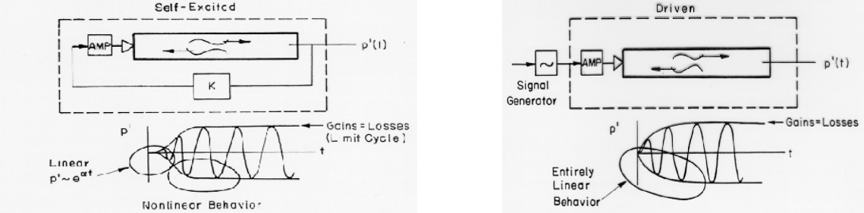

Structural vibrations of a solid rocket are not normally in°uential, but an instability of the bulk mode (there is only one bulk mode for a given geometry) has often been a problem in motors designed for use in space vehicles.the gains exceed the losses in the frequency range f1 <f<f2. Modes having frequencies in that range will therefore be linearly unstable

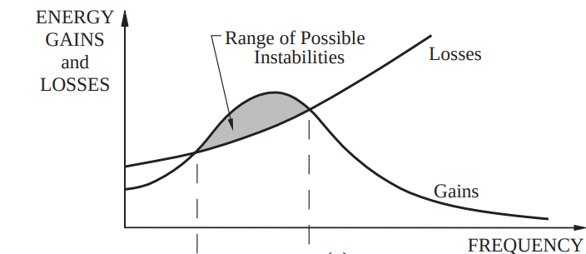

Gains and Losses of Acoustic Energy; Linear Stability. It is a general result of the theory of linear systems that if a system is unstable, a small disturbance of an initial state will grow exponentially in time: amplitude of disturbance » e®g t

***Internal propulsion systems in rockets***

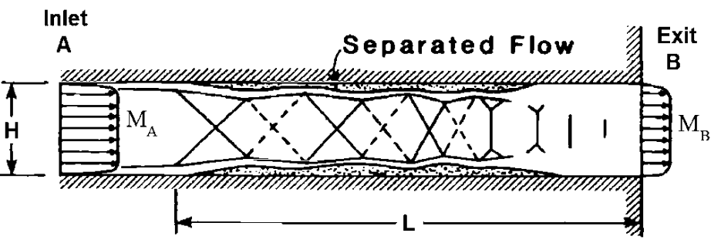

**Real cycles for engines**

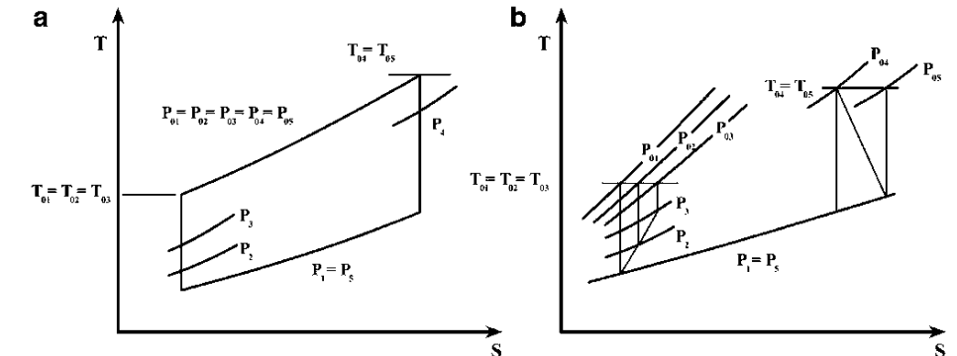

**Station 1** is downstream of the vehicle forebody shock and represents the properties of the flow that enters the inlet.

**Station 2** is at the inlet throat, which is usually the minimum area of the flow path, and the isolator extends between stations 2 and 3.

**Station 3** represents the start of the combustor, where fuel and air is mixed and burned.

**Station 4** represents the end of the combustor. Station 5 represents the end of the expansion process, which includes an internal expansion within the nozzle and an external expansion to the end of the vehicle.

**Isolator**

Isolator outlet pressure ratio to its dimensions, inlet Mach number, and boundary layer parameters at inlet. In Eq & the L/Hare isolator dimensions according to the equation, **θ** is the momentum thickness at the isolator inlet, and **Rθ** is the Renoldes number related to momentum thickness. In the process of the adiabatic supersonic flow with adiabatic compression efficiency defined by a given combustion.

**Combustion**

The burning process is modeled as a Rayleigh flow. When the Mach number at the combustion chamber is supersonic, the combustion chamber will be similar to the scramjet combustion. Combustion chamber outlet data is obtained using Rayleigh flow and energy.

**Synthesis(Python)**

| T4,**T3** ¼ M4,M3  **(" #2 1 þ γcM3)**  2 cycles  **(1 þ γhM4)**  2 cycles  " #2 |
| --- |

**Parameters**

The momentum thickness is θ **¼ 3**mm, height of isolator **H ¼ 0:08m,** and Reynolds number based on momentum thickness boundary layer is **Reθ ¼ 3 , 105**

* Specific thrust and thrust specific fuel consumption
* Thermal efficiency, propulsive efficiency, and overall efficiency
* Mach number of gasses leaving scramjet
* Isolator length $ L)

(Python)At altitude 27,000 m Temperature and pressure are:

| **T1 ¼ 222:66**k P1 ¼ 1,  823**Pa M1** ¼ 7:0 V1 ¼ M1 γIRT1 p ¼ 2,  093:**7m=s** T01 ¼ T1 1 þ 0:5,  γð Þ c % **1 M2 1** ' ( ¼ 2405 K  P01 ¼ P1 1 þ 0:5 , γð Þ c % 1 M2 1 ' **(3:5 ¼ 7, 547 kPa)** |
| --- |

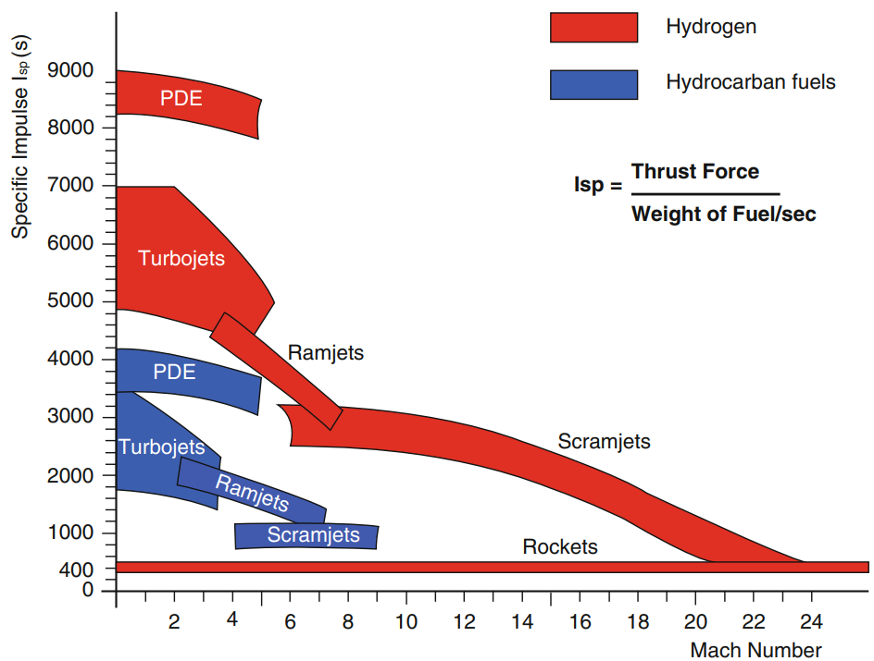

***Components***

**Oxidizer:** Oxidizer source, AP-AN (0-70 %)

**Metal Fuel:** Primary fuel source, Al, B, Be, Zr, (0-30 %)

**Fuel Binder:** Holds the grain in one piece, also fuel, (HTPB, PU, PVC), (5-18 %)

**Curing Agents:** Polymerization and cross linking agents, DDI, (1-3.5 %)

Burn Rate Modifiers: Combustion mechanisms, FeO (0.2-3 %)

**Explosive Fillers:** Smoke control, HMX, RDX (0-40 %) – Plasticizers: Improve elongation capability, ease of processing (various liquids)

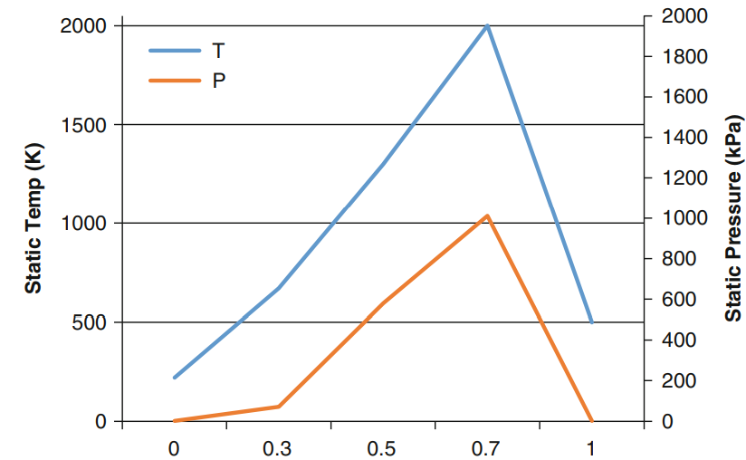

**Variables;**

1. Air mass flow rate into engine

2. Exhaust velocity

3. Maximum temperature inside the engine

4. Maximum pressure

5. Thrust specific fuel consumption (TSFC)

6. Average range

**Description;**

The idealized thrust–time profile that corresponds to the idealized sinusoidal combustor pressure–time profile.the thermal efficiency is expressed by;

| ηth ¼ **1 % ð Þ** |
| --- |

A single ramjet engine powering an airplane flying at stratosphere region of the standard atmosphere, where **Ta ¼constant**, prove that the thrust is expressed by the relation:

**Variables to compute**

| T ¼ **m_ a**  **τb**  p  ð Þ % 1 where τb ¼ T03  **T02** |
| --- |

If the maximum temperature **To4 ¼constant** (full-throttle operation), prove that the thrust attains a maximum value when the flight Mach number Mo.

**Issues in rocket propulsion**

Detonation vs Deflagration

Detonation wave speed: 2,000-9,000 m/sec

Deflagration wave speed: 0.002-0.05 m/sec

• Typical Composite Propellant: AP (70% by weight), Al (16% by weight), Binder (12% by weight) • Typical Double-Base Propellant (JPN): Nitrocellulose (51.5% by weight), Nitroglycerine (43.0 % by weight)

• Typical Composite Modified Double-Base (CMDB): AP (20.4% by weight), Al (21.1% by weight), Nitrocellulose (21.9% by weight), Nitroglycerine (29.0 % by weight)

• Gas Generators: Alkali Azides (NaN3 or KN3) with oxides (low temperature products)

• Igniters: Mg+Teflon, B+KN+Binder (Rapid heat release)

ORBUS 21 Space Motor (CSD/UTC)

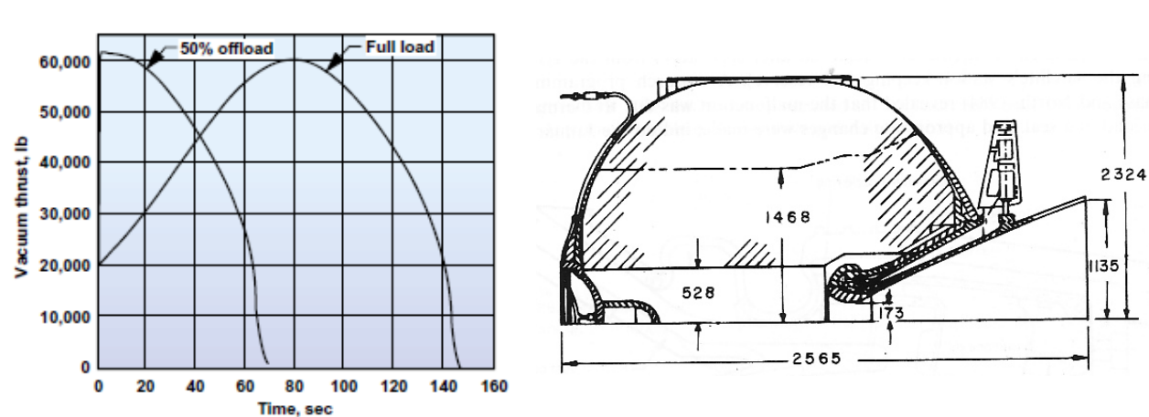

3-D Fuel grain geometry determines F-t Active control is very hard to implement Offloading is possible (use same motor for different missions) Flex joint for Thrust Vector Control (TVC)

**Rocket-example**

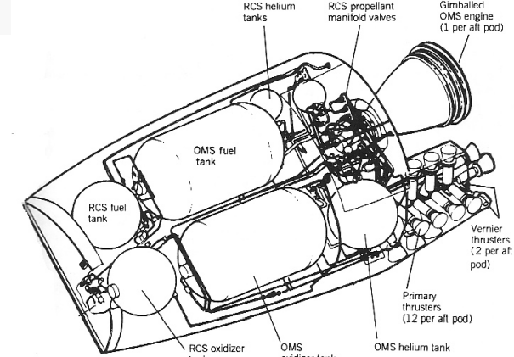

Propellant, igniter, Nozzle and Insert

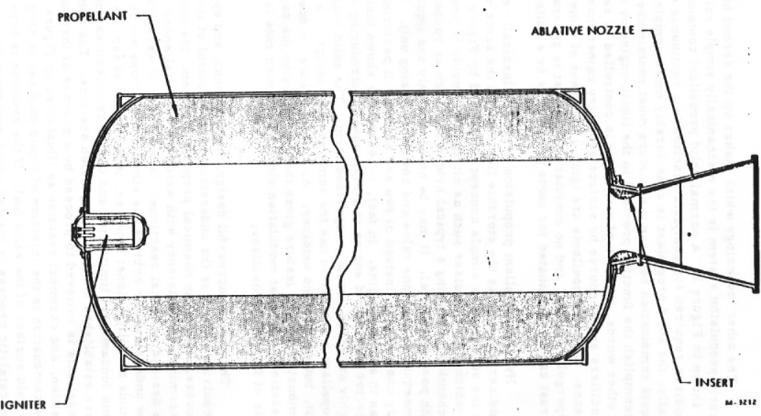

**Practical review;**

A ramjet has low-speed stagnation pressure losses given by rd ¼ 0:90; rc ¼ 0:95; rn ¼ 0:96. The ambient and maximum temperatures are 225 K and 2000 K, respectively. The fuel-to-air ratio is assumed very small such that f << 1

A ramjet engine is fitted with a variable geometry intake, where a center body moves forward or backward to adjust the oblique shock wave to the intake lips;

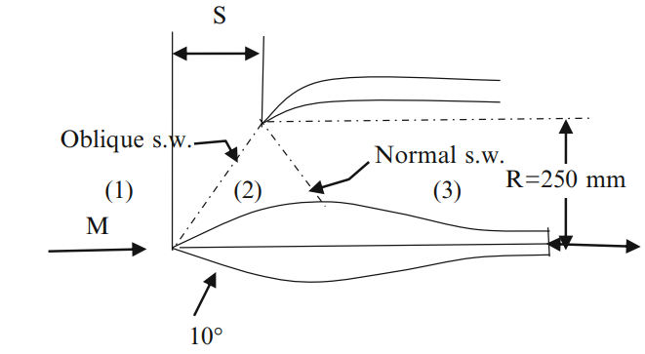

**Applications of mathematical synthesis in rocket-propulsion**

**Launch vehicles:**

– Core propulsion, Booster, Upper stage propulsion, Separation rockets

• Civilian sub-orbital applications (other than ballistic missiles)

– Space tourism, rapid delivery

• Space applications – Orbit transfer (GTO to GEO transfer) – In space propulsion (main propulsion system, planetary landing, orbit insertion) – Attitude control systems

• Military applications – Ballistic missiles, Tactical weapon systems, Target drones

(a) The fuel-to-air ratio

(b) The nozzle exit area for the two nozzle cases: choked (convergent nozzle) and unchocked (de Laval nozzle)

(c) The thrust force in the two above cases (d) d-TSFC in the two above cases.

| P02  **P0a**  ¼ 1 % 0:1ð Þ **M % 1 1:5** |
| --- |

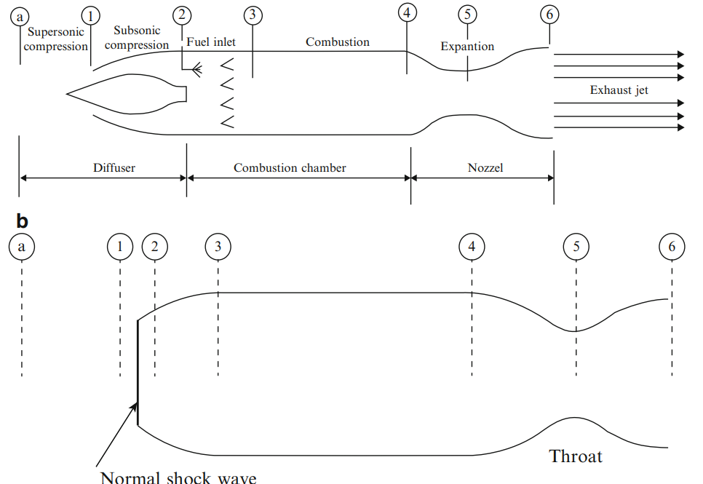

A ramjet operates at an altitude of 10,000 m ðTa ¼ 223 K, Pa ¼ 0:26 atm, γ ¼ 1:4Þ at a Mach number of 1.7. The external diffusion is based on an oblique shock and on a normal shock;

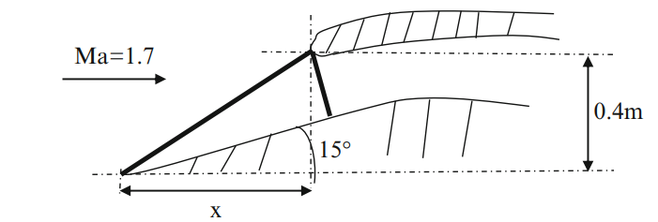

Supersonic configuration having an axisymmetric layout and fitted with a spike having a deflection angle 12o . Typical subsonic intake with a normal shock just at inlet. The following data applies for both layouts. Combustion chamber has a cylindrical shape with a constant cross sectional areaAcc 1 ⁄ 4 0:2m2. The maximum total temperature in the combustion chamber is 2500 K. Heating value of fuel is 45,000 kJ/kg. The burner efficiency is ηb ¼ 0:96.

The nozzle expands to atmospheric pressure for maximum thrust with ηn ¼ 0:96. The velocity entering the combustion chamber is to be kept as large as possible but the Mach number must not exceed 0.25. Assuming (γair ¼ 1:4, γgases ¼ 4=3), compute: (a) The stagnation pressure ratio of the diffuser (rd) (b) The inlet Mach number to the combustion chamber (c) The stagnation pressure ratio in the combustion chamber (rc) (d) The stagnation pressure ratio in the nozzle (rn) (e) The flight and exhaust speeds (f) Inlet and outlet areas (Ai, Ae)

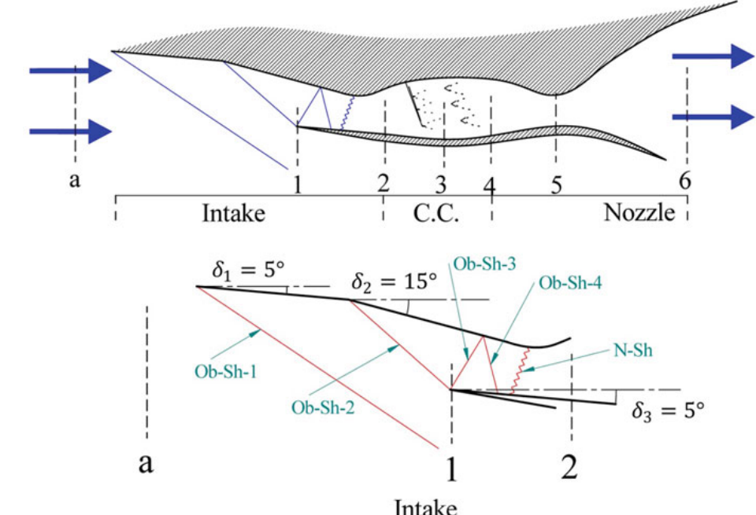

Flight Mach number Ma ¼ 2:0 Flight altitude is sea level where ambient pressure Pa ¼ 101 kPa Maximum total temperature Tomax ¼ 2000 K Pressure recovery of intake (diffuser) rd ¼ 0:90 Pressure recovery of combustion chamber rcc ¼ 0:98

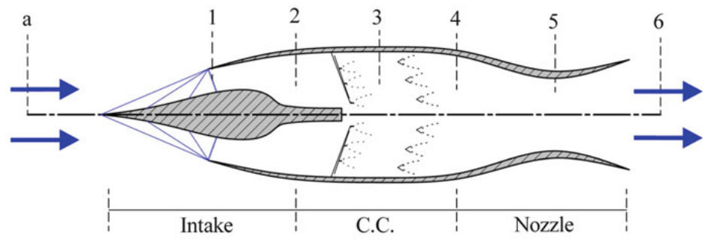

Flight Mach number Ma ¼ 2:4

Flight altitude is 61,000 m where ambient pressure Pa ¼ 18 kPa and ambient temperature Ta ¼ 252:5 K Maximum total temperature Tomax ¼ 2000 K Pressure recovery of intake (diffuser) rd ¼ 0:80 Pressure recovery of combustion chamber rcc ¼ 0:98 Pressure recovery of nozzle rn ¼ 0:96 Constant properties of fluid inside the engine are assumed: γ ¼ 1:4 ; Cp ¼ 1005 J=ð Þ

**Oxidizers for rocket propulsion**

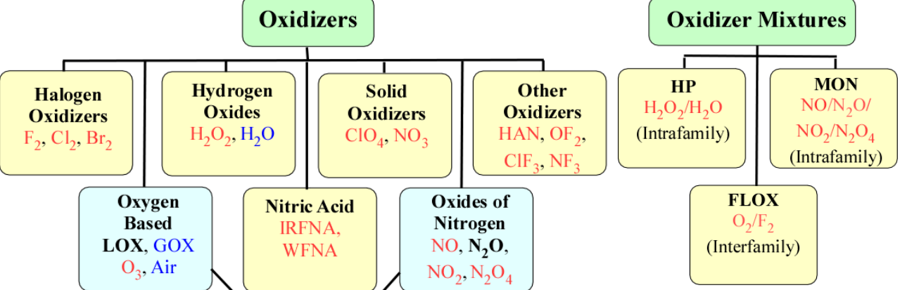

A new class of oxidizers with favorable properties can be formulated as equilibrium and non-equilibrium mixtures of N2O and O2 . N2O is the densifying component and O2 serves as the pressurant. Nytrox has a number of advantages over the pure components.

**Gasses;**

Gas phase mixtures of N2O and O2 are commonly used in medical and dental applications as an anesthetic. Equilibrium liquid/vapor mixtures of N2O and O2 have been studied to demonstrate safe storability at low temperatures.

**Experimental data on the mixtures of N2O/O2 exists**

Compared to LOX and N2O Benign nature of the pure components is retained. Self pressurization is possible at high densities. Optimization possible based on mission requirements. Non-equilibrium mixtures can be used to improve the system performance significantly. Efficient vapor phase combustion. Improved delivered Isp.

**Cryogen in oxidizers components to refrigerate the cameras-system of the rocket engines;**

Oxidizer at -60 C or -40 C is much easier to manage. Composite tanks can be used. These temperatures are ideal for MAV.

* Self pressurization at high density,
* Reduced sensitivity
* Nytrox outperforms N2O4 at the corresponding oxygen mass fraction
* High impulse density with self-pressurization
* Nytrox is safer compared to pure N2O because of the dilution effect of oxygen in the vapor phase.
* Vapor phase is primarily composed of oxygen

**Propellants-fuels(specifications)**

**Nitrogen Containing Fuels:**

• Ammonia (NH3): – Liquid, good Isp performance with various oxidizers

• Amines: – Organic derivatives of ammonia – Replace the hydrogen atom with organic radicals (example: methyl group)

– Examples

• Methylamine ((CH3) NH2): gas under ambient conditions

• Dimethylamine ((CH3)2NH): gas under ambient conditions

• Trimethylamine ((CH3)3N): liquid under ambient conditions • Aniline ((C6H6)NH2): Replace hydrogen with a benzene ring, oily liquid (poison) – Amines are used as additives to the liquid propellants to enhance the combustion stability behavior of liquid engines

**Others**

(ONO2) group + organic radical – Very flammable and highly explosive

– Methyl Nitrate (Monopropellant): liquid – Nitrocellulose

• Solid material of variable composition

• Empirical formula C6H7O2(ONO2)3

• Used in double based solid propellants

• Low Isp, good explosive (containing its own oxygen)

– Nitroglycerin (C3H5(ONO2)3):

• Liquid at room temperature

• Low Isp

• Used in the production of dynamite

**Metals**

**Metals:** – High heat of combustion but limited Isp improvement due to • High dissociation, Tc is limited due to dissociation

• Also high MW of products

• Aluminum (Al): – Extensively used as the prime fuel in solid rockets, additive in hybrid rockets – Not toxic (can be harmful if inhaled in the dust form) – Fairly easy to handle, available and relatively inexpensive in micron size – Generally in the powder form • Micron size

• Nano size (low Isp, high efficiency, high burn rate) – Enhances the heat of combustion as an additive

• Effective in energy deficient systems (storable or solid oxidizers) – H2O2, N2O, N2O4, IRFNA, AP, AN – Lower temperature and less dissociation

• No gain with LOX, energy gain diminishes due to dissociation

• Beryllium (Be): – Extremely high energy – Powder in crystalline phase – Highly toxic, both acute and also chronic, carcinogenic

**Turbine-Based Engines: Turbojet, Turbofan, and Turboramjet Engines**

**(423)**

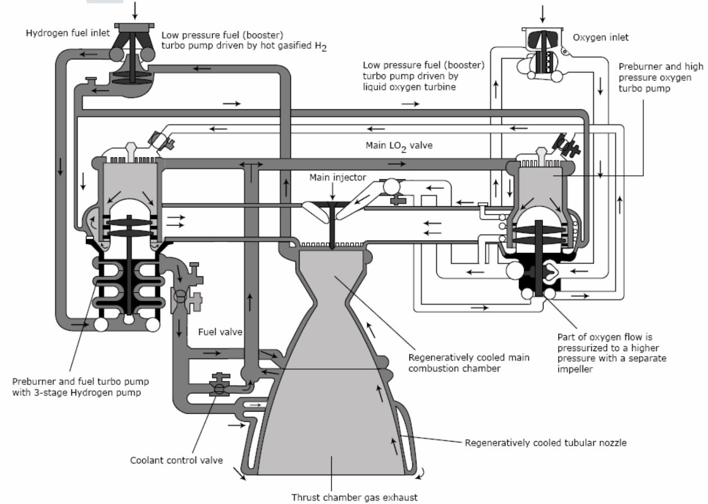

**Chemical-kinetics**

I want to use synthesis tools such in circuits and boolean algebra to measure reactions in rocket combustion engines with some particular examples.

**Digital electronics in aerospace for satellite CPUs**

* The most important thing to take in consideration at the time we design some aspects of circuits is the internal boolean arithmetic of components that transport signals up to 0.3 And the registers that store the information given in ASCII keywords from the devices.
* Synthesis tools
* Logic design (microchips)

**Electronic diagram for circuit design**

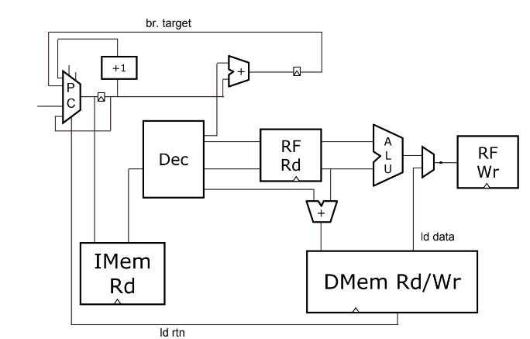

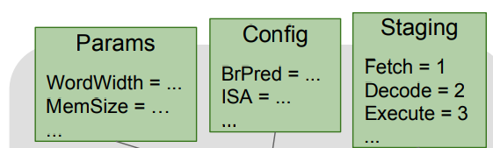

○ Combinational Logic

○ Sequential Logic

○ Pipelines

○ Validity

○ Pipeline Interactions

○ Hierarchy

**Vectors with 5 bits per data-transaction**

| $out[4:0] = $in1[3:0] + $in2[3:0]; |
| --- |

Waveform (values are in hexadecimal and addition can overflow)

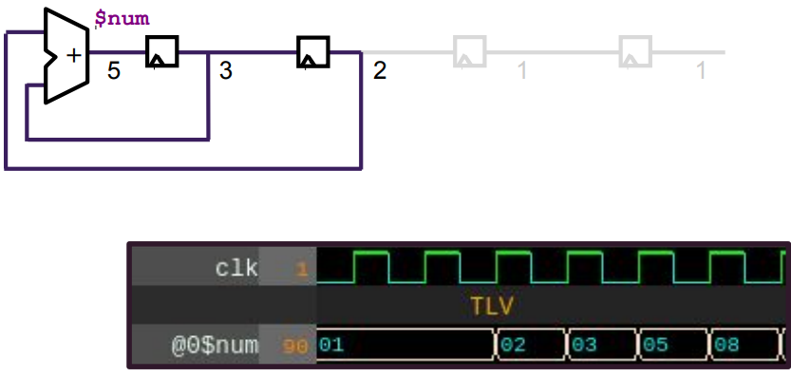

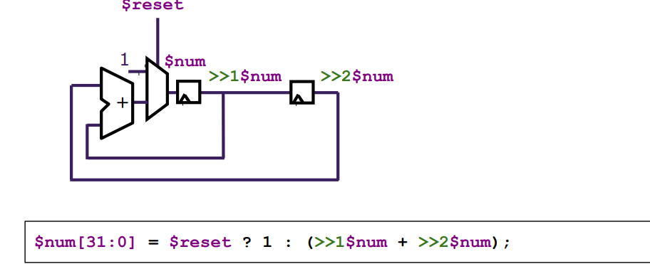

| $aa_sq[31:0] = $aa * $aa;  $bb_sq[31:0] = $bb * $bb;  $cc_sq[31:0] = $aa_sq + $bb_sq;  $cc[31:0] = sqrt($cc_sq); |
| --- |

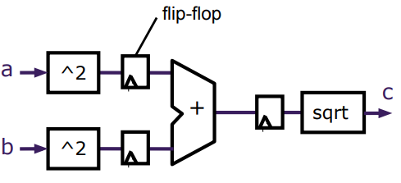

Logic & synthesis

| // Calc Pipeline logic [31:0] a_C1; logic [31:0] b_C1;  **logic [31:0] a_sq_C1, a_sq_C2;**  logic [31:0] b_sq_C1, b_sq_C2;  logic [31:0] c_sq_C2, c_sq_C3;  logic [31:0] c_C3;  always_ff **@(posedge clk)** a_sq_C2 <= a_sq_C1;  always_ff @(posedge clk) b_sq_C2 <= b_sq_C1;  always_ff @(posedge clk) c_sq_C3 <= c_sq_C2;  **// Stage 1 assign** a_sq_C1 = a_C1 * a_C1;  assign b_sq_C1 = b_C1 * b_C1;  **// Stage 2 assign** c_sq_C2 = a_sq_C2 + b_sq_C2;  // Stage 3 assign c_C3 = sqrt(c_sq_C3); |
| --- |

Arithmetic units are one of the most important things for designing submodules in a circuit.

Logic-Blocks, timers, interrupters, AVR ports or any kind of specification in the chip

Clocks in two phases, catching the delay errors.

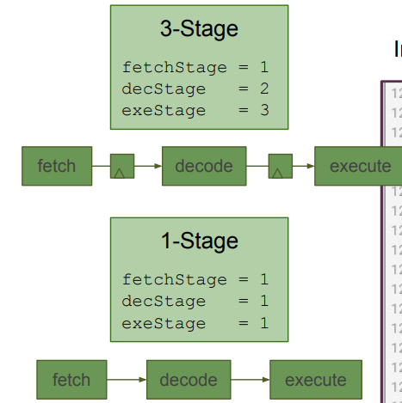

| **|fib @1** $num[31:0] = **$reset** ? 1 : (>>1$num + >>2$num); |
| --- |

**Clock(timers) specifications;**

Clock signals are distributed to EVERY flip-flop.

○ Clocks toggle twice per cycle.

○ This consumes power.

● Clock gating avoids toggling clock signals.

● FPGAs generally use very coarse clock gating + clock enabled.

● TL-Verilog can produce fine-grained gating or enables.

**MUX** (Hardware description diagram)

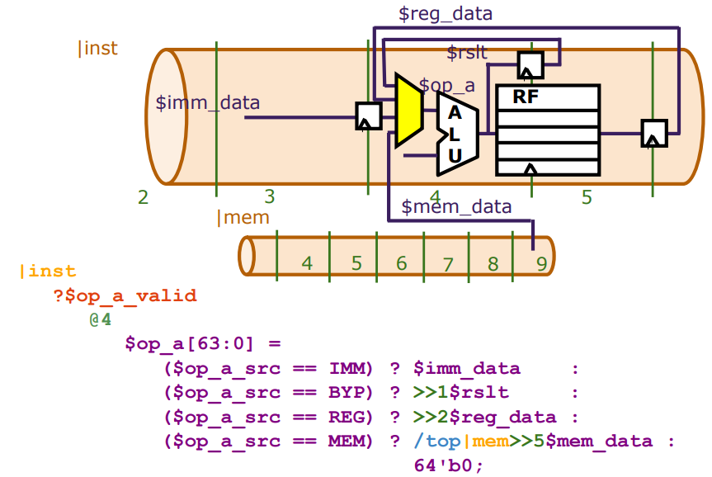

Register bypass is another important aspect to regulate the delay or timing errors with flip-flops

Due circuit design. Just take a few moments verify in the code compiling the block the signals for register-bypass;

In order to optimize errors we need to establish some rules for digital circuits and register cycles. One of the rules is the two stages or phases per clock to avoid rate conditions, another important thing is try to verify or simulate the signals with tests in Arduino simulators.

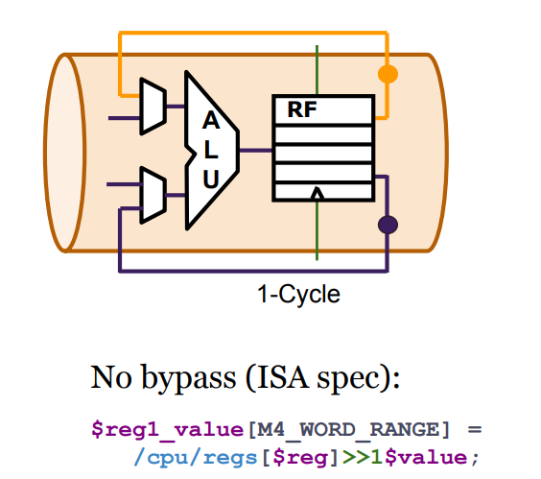

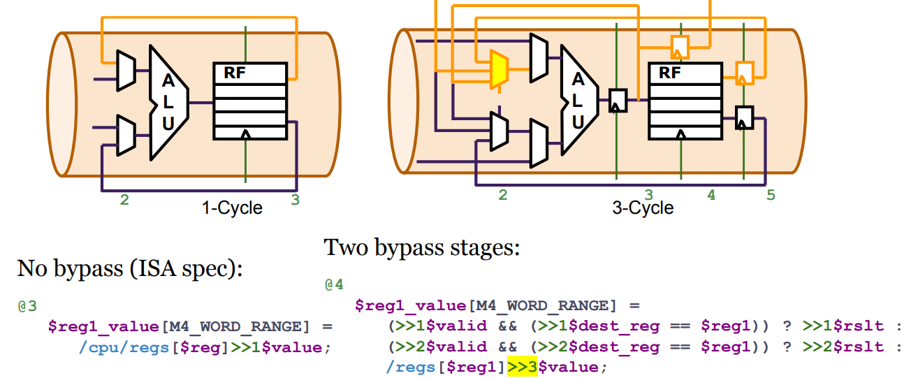

Verilog functions and Macros in C offers hierarchical structures to the programmer for the hardware descriptions:

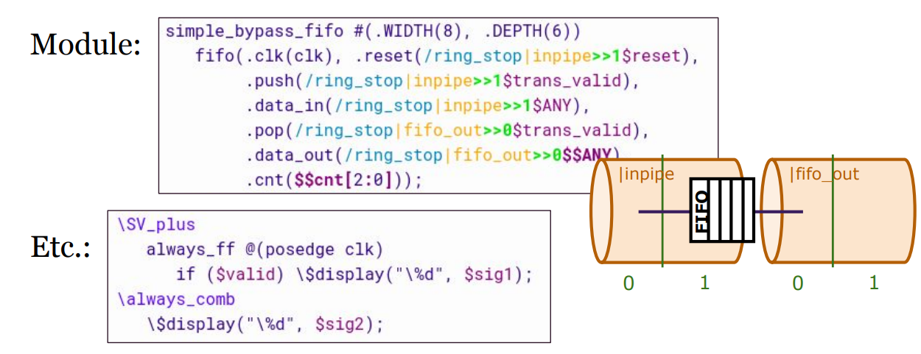

**File-structure;**

ASCII, Hexadecimal converters and byte operations require boolean operations & also, boolean properties to structure the circuit path in logic blocks properly, synthesize the arithmetic in functions;

| **\TLV_version 1b tl-x.org**  \SV module my_design  ( input clk, input valid, input [31:0] data_in, output [31:0] data_out ); \TLV |
| --- |

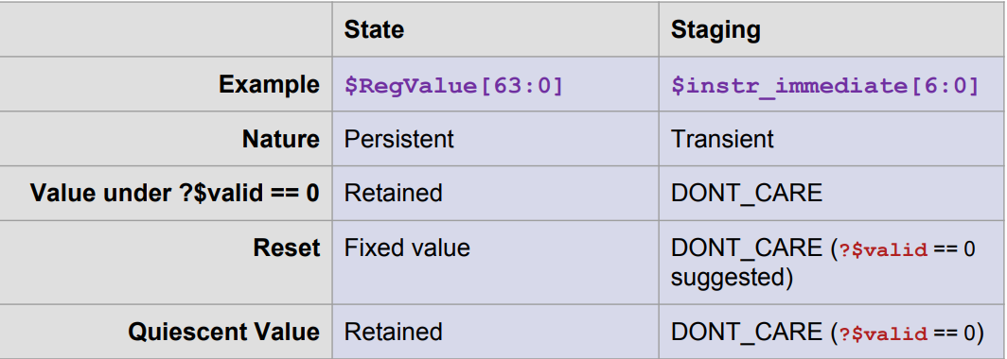

| |calc ?$valid @1 $aa_sq[31:0] = $aa * $aa;  **$bb_sq[31:0] = $bb * $bb;**  @2 $cc_sq[31:0] = $aa_sq + $bb_sq;  @3 $cc[31:0] = sqrt($cc_sq);  **@4 $TotDist[31:0] <= $reset ? 0 : $TotDist + $cc;** |
| --- |

**Arithmetic;**

You can compute a circuit to know a certain distance in a geometrical and graphical way like this example diagram;

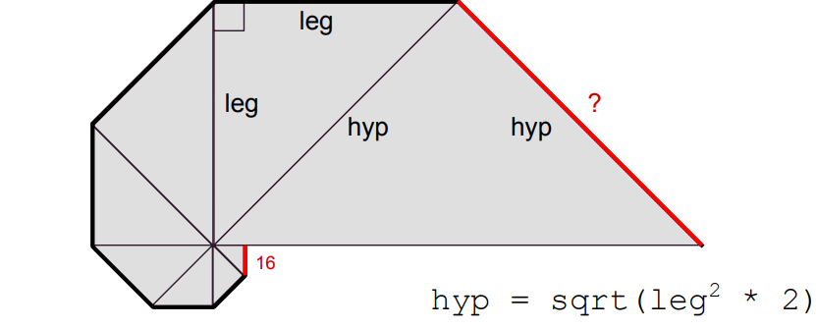

**Specific arithmetic for the internals of the circuit:**

* Addition
* Subtraction
* Multiplication
* Division

Functions and registers ASCII-Keys in devices(internals)

| byte keys_state[KEYS_NUMBER];  unsigned long keys_time[KEYS_NUMBER];  boolean signals[KEYS_NUMBER * 2]; |
| --- |

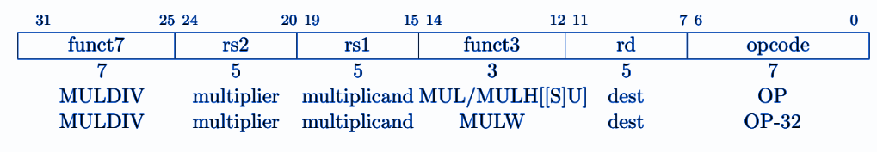

XLEN-bit×XLEN-bit multiplication and places the lower XLEN bits in the destination register. MULH, MULHU, and MULHSU perform the same multiplication but return the upper XLEN bits of the full 2×XLEN-bit product, for signed×signed, unsigned×unsigned, and signed×unsigned multiplication.

Functions and registers ASCII-keys and byte-signals up to 0.2-0.3 Voltios

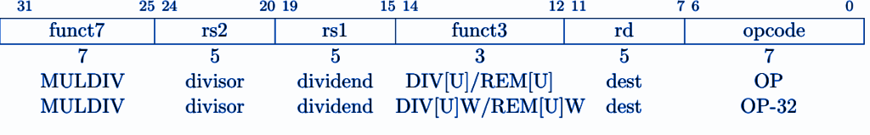

**Arithmetic(Division)**

DIV and DIVU perform signed and unsigned integer division of XLEN bits by XLEN bits. REM

and REMU provides the remainder of the corresponding division operation. If both the quotient

and remainder are required from the same division, the recommended code sequence is: DIV[U] rdq, rs1, rs2; REM[U] rdr, rs1, rs2